Group by clause:
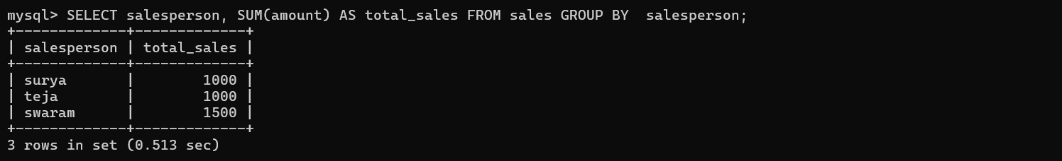

HAVING Clause:

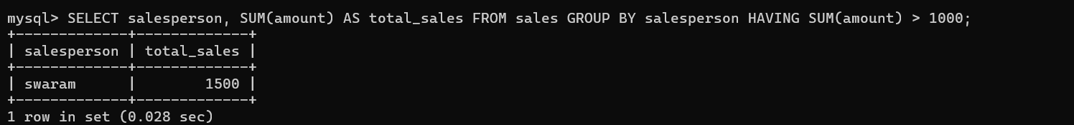
ORDER BY Clause:
